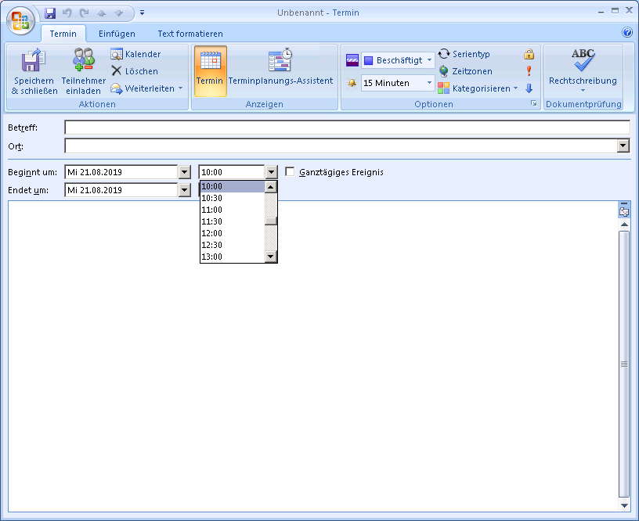

(42)

For selection of time it should be that drop down menu – what you mean?

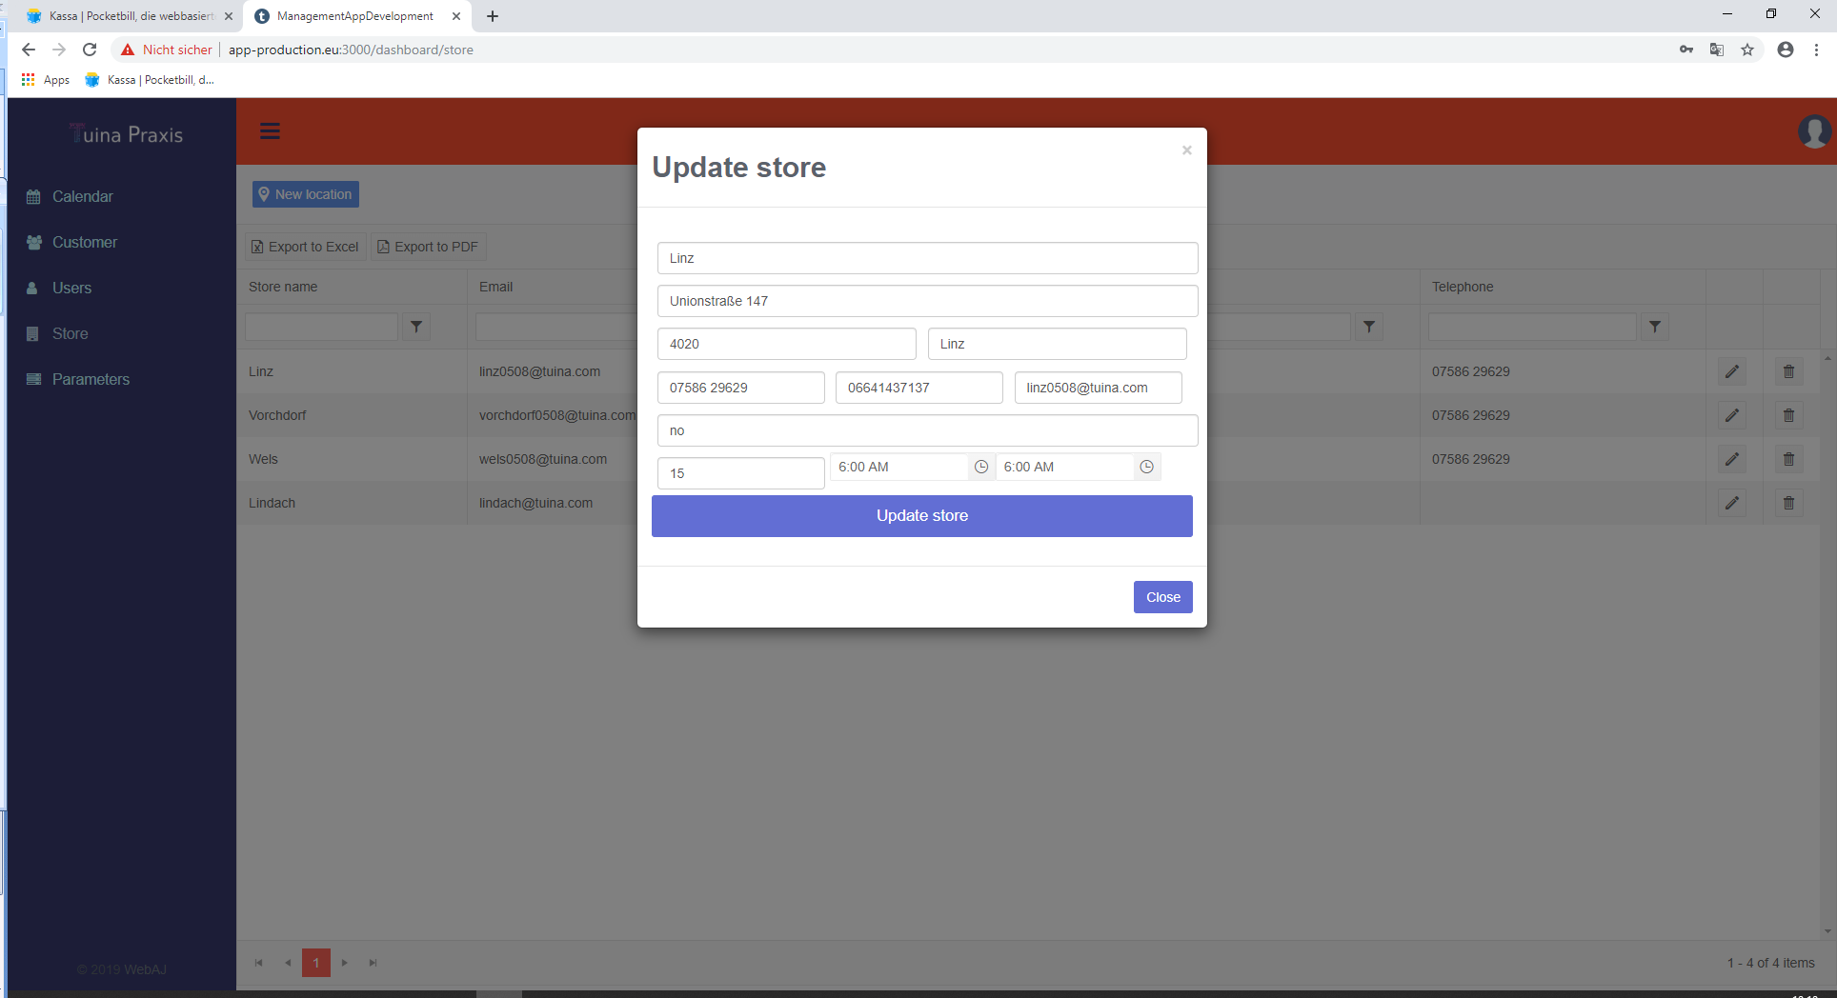

(43) = (27)   
Calendar / The distance between for example 8:00 and 9:00 can be closer (should be set up at the store).  
And the working time should be continuous over the whole time (i.e. 8-12, and 13-18, see graphic)

Field Duration is needed to set a standard duration for therapy – this parameter should not affect to the time grid.

And we need a second parameter for each store like time grid to define the time distance in the calendar. Now it I 1h, but also any different time grids should be possible

Examples

1h  
08:00  
09:00  
10:00

---

30min  
08:00  
08:30  
09:00  
09:30  
10:00

---

40min  
08:00  
08:40  
09:20  
10:00

---

15min  
08:00  
08:15  
08:30  
08:45  
09:00

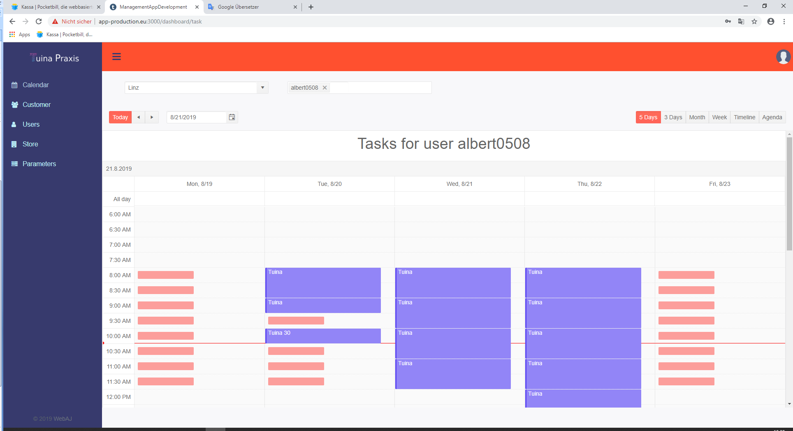

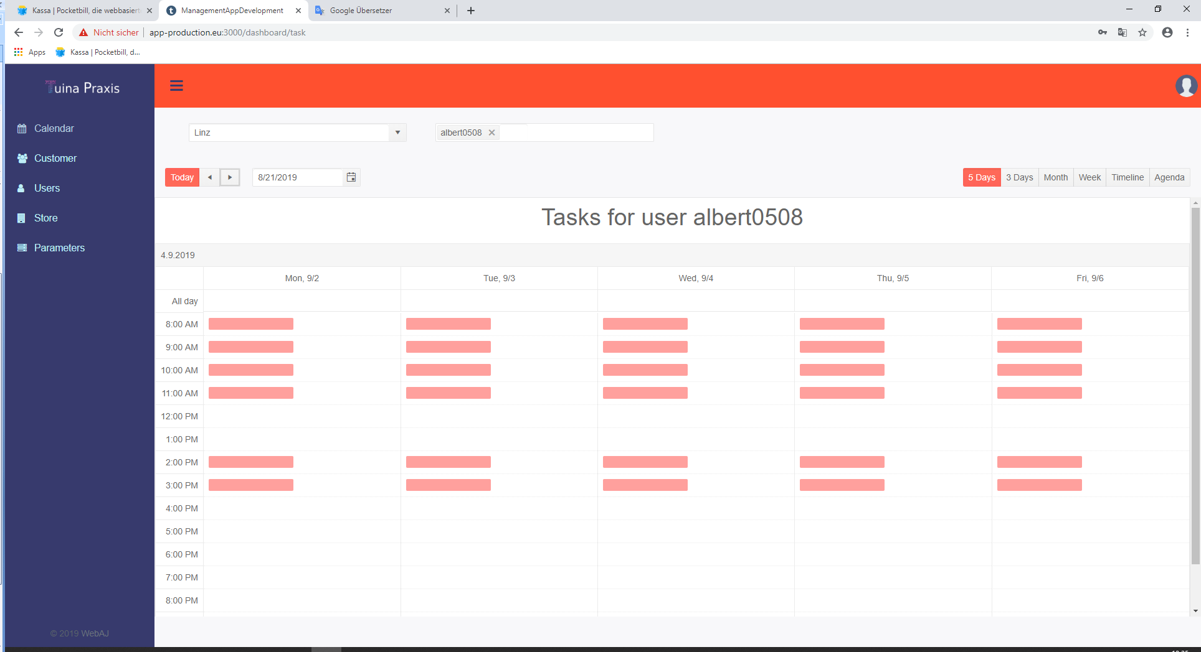

The background color for the working time should be one colored area which is going through, in this case from 8-12 and from 2-4

(44) = (26)

For each store we need a field “duration of therapy”. There you can define for example 0,5h, 0,75h, 1h, 2h, etc. Than you can define the default “duration of therapy”, for example 1h. Than when a new event will be set up in the calendar, this default value (i.e. 1h) should be used.

I define duration 30min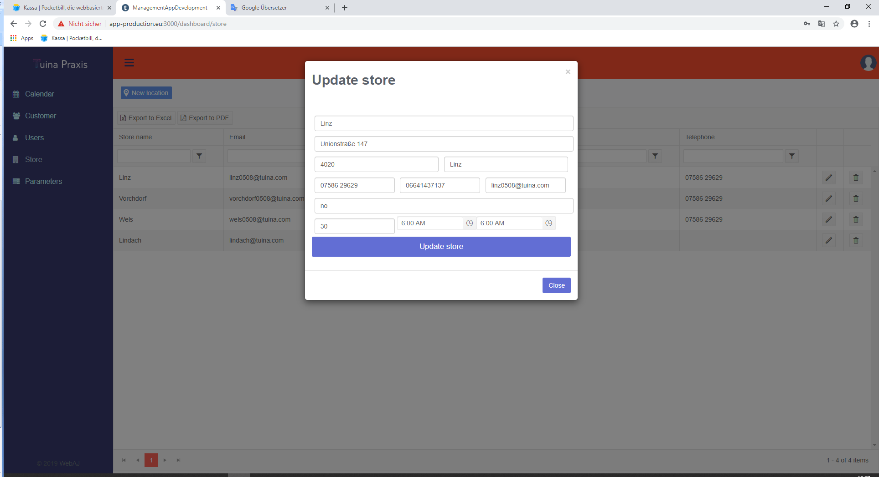

But the duration is 1 hour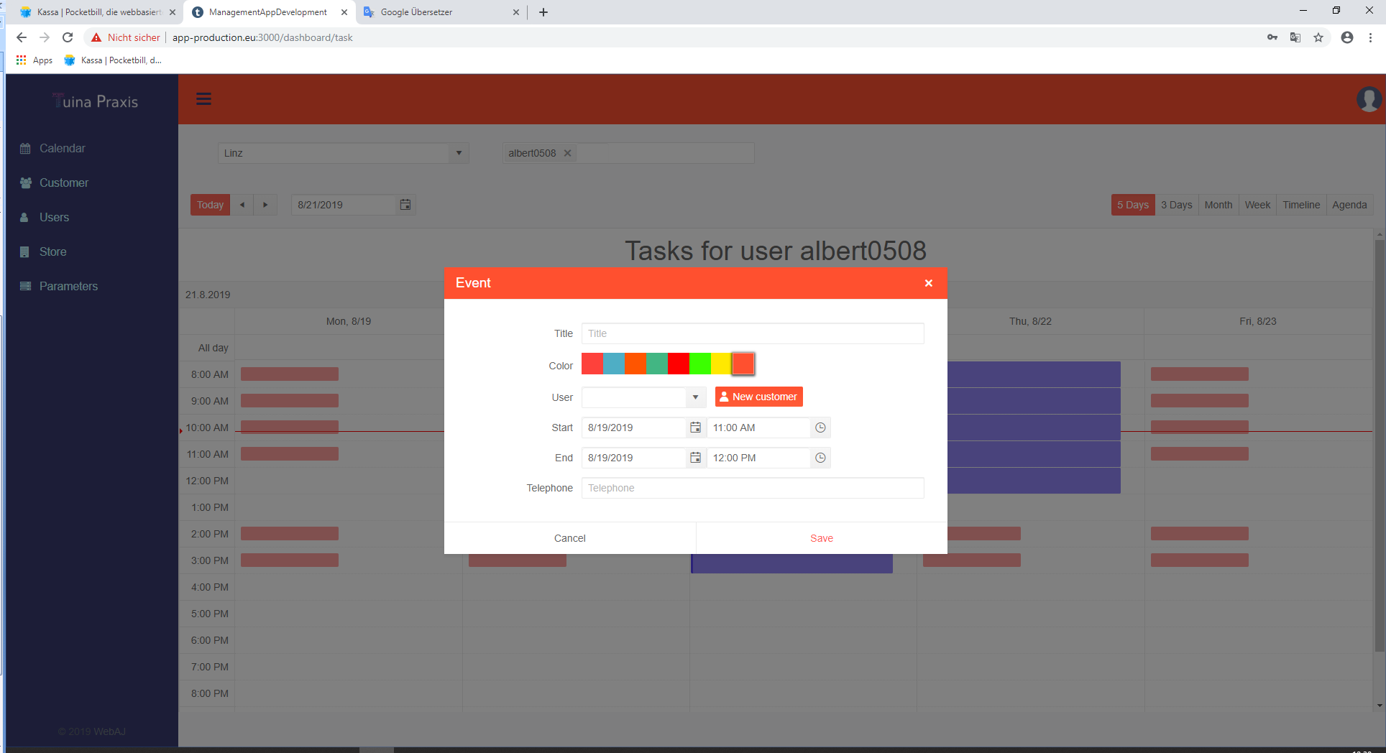

(45)

**Than the bigger change for the Event Window:**

We have to move the field User to the top and name it as Patient (User) and the field title under that field and name it Beschwerde (Complaint)

Under that field we need the field Therapie (therapy)

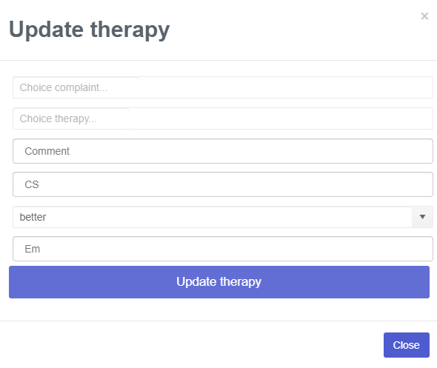

And the fields like in therapy.

(

(48)

Calendar / fix line

The line “KW35 Tasks for user xxx” should also be fixed at the top

(49) = (46) =(12)

At Parameters and Customer / Therapies  
  
Table “former Therapies” with the fields Therapy and a second field to define the order.

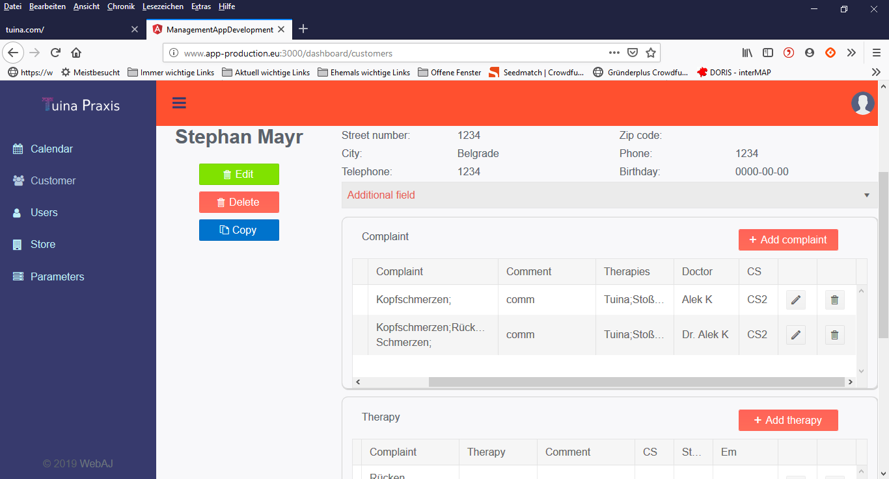

Customer / Complaint

The field “Therapies” should be a separate field “former therapies” as described in (46) = (12)

It defines therapies that where made before the customer came to us. Like physio, orthop, etc. It should be defined in the parameters

(50)

We need at every inputs the name of the field in front or over the input field, like it is at the event window.